开源项目库
我感觉这个东西和python的 pip类似

http://mvnrepository.com/open-source

很多很多
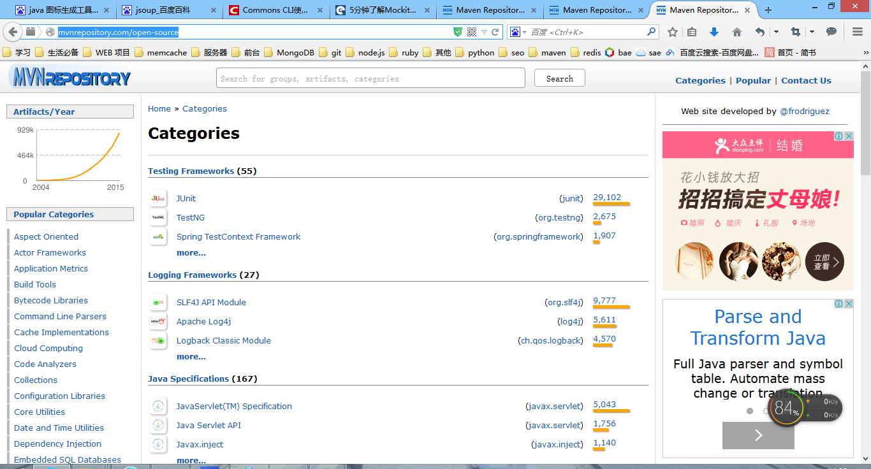

mysql驱动

<!-- 加入mysql -->
<dependency>
<groupId>mysql</groupId>
<artifactId>mysql-connector-java</artifactId>
<version>5.1.35</version>
</dependency>

redis驱动
<!--加入redis-->
<dependency>
<groupId>redis.clients</groupId>
<artifactId>jedis</artifactId>
<version>2.6.0</version>
</dependency>

mongodb驱动
<!--加入monogodb-->

<dependency>
<groupId>org.mongodb</groupId>
<artifactId>mongo-java-driver</artifactId>
<version>2.13.0</version>
</dependency>

<!--加入memcache-->

log4j
<!-- 加入log4j -->
<dependency>
<groupId>log4j</groupId>
<artifactId>log4j</artifactId>
<version>1.2.16</version>
</dependency>

hibernate
<!-- 加入hibernate -->
<dependency>
<groupId>org.hibernate</groupId>
<artifactId>hibernate-core</artifactId>
<version>3.6.10.Final</version>
</dependency>

junit
<!-- 添加测试 -->
<dependency>
<groupId>junit</groupId>
<artifactId>junit</artifactId>
<version>4.10</version>
<!-- 运行时加入 -->
<scope>test</scope>
</dependency>

spring data mongodb
<!-- 导入spring data mongodb -->
<dependency>
<groupId>org.springframework.data</groupId>
<artifactId>spring-data-mongodb</artifactId>
<version>1.7.0.RELEASE</version>
</dependency>

spring data redis
<!-- 导入spring-data-redis -->
<dependency>
<groupId>org.springframework.data</groupId>
<artifactId>spring-data-redis</artifactId>
<version>1.5.0.RELEASE</version>
</dependency>

spring mvc 和spring
<!-- 导入spring -->
<dependency>
<groupId>org.springframework</groupId>
<artifactId>spring-core</artifactId>
<version>3.2.3.RELEASE</version>
</dependency>
<!---aop 面向切面->
<dependency>
<groupId>org.springframework</groupId>
<artifactId>spring-aop</artifactId>
<version>4.1.6.RELEASE</version>
</dependency>
<!---aspectj 面向切向->
<dependency>
<groupId>aspectj</groupId>
<artifactId>aspectjrt</artifactId>
<version>1.5.3</version>
</dependency>

<!-- 导入spring mvc -->

<dependency>
<groupId>org.springframework</groupId>
<artifactId>spring-webmvc</artifactId>
<version>3.0.5.RELEASE</version>
</dependency>

<dependency>
<groupId>org.springframework</groupId>
<artifactId>spring-core</artifactId>
<version>4.1.6.RELEASE</version>
</dependency>

beanutils
<!-- 导入bean的 操作工具 -->
<dependency>
<groupId>commons-beanutils</groupId>
<artifactId>commons-beanutils</artifactId>
<version>1.9.2</version>
</dependency>

commons-io工具
<!--io-->
<dependency>
<groupId>commons-io</groupId>
<artifactId>commons-io</artifactId>
<version>1.1</version>
</dependency>

<dependency>
<groupId>commons-io</groupId>
<artifactId>commons-io</artifactId>
<version>1.4</version>
</dependency>

<dependency>
<groupId>commons-io</groupId>
<artifactId>commons-io</artifactId>
<version>2.4</version>
</dependency>

commons-dbcp
配置数据库连接池

validator
<!--导入验证器-->
<dependency>
<groupId>commons-validator</groupId>
<artifactId>commons-validator</artifactId>
<version>1.4.0</version>
</dependency>

dom4j

<!--导入dom4j-->
<dependency>
<groupId>dom4j</groupId>
<artifactId>dom4j</artifactId>
<version>1.6.1</version>
</dependency>

dwr
<!--导入dwr-->
<dependency>
<groupId>org.directwebremoting</groupId>
<artifactId>dwr</artifactId>
<version>3.0.M1</version>
</dependency>

jstl
jsp网页中调用的
<!--导入jstl-->
<dependency>
<groupId>jstl</groupId>
<artifactId>jstl</artifactId>
<version>1.2</version>
</dependency>

<dependency>
<groupId>taglibs</groupId>
<artifactId>standard</artifactId>
<version>1.1.2</version>
</dependency>

站内查询
<!--导入lucene-->
<!-- 导入lucene -->
<dependency>
<groupId>org.apache.lucene</groupId>
<artifactId>lucene-core</artifactId>
<version>3.5.0</version>
</dependency>
<!-- 高亮显示 -->
<dependency>
<groupId>org.apache.lucene</groupId>
<artifactId>lucene-highlighter</artifactId>
<version>3.5.0</version>
</dependency>
<!-- 分词器 -->
<dependency>
<groupId>com.chenlb.mmseg4j</groupId>
<artifactId>mmseg4j-analysis</artifactId>
<version>1.8.6</version>
</dependency>

<dependency>
<groupId>org.apache.tika</groupId>
<artifactId>tika-core</artifactId>
<version>1.4</version>
</dependency>

tika
<!--导入tika-->

itext操作pdf
<!--导入itext-->
<dependency>
<groupId>com.itextpdf</groupId>
<artifactId>itextpdf</artifactId>
<version>5.4.4</version>
</dependency>

mybatis
<!--导入Mybatis-->
<dependency>
<groupId>org.mybatis</groupId>
<artifactId>mybatis</artifactId>
<version>3.2.3</version>
</dependency>

<!--导入spring的mybatis-->
<dependency>
<groupId>org.mybatis</groupId>
<artifactId>mybatis-spring</artifactId>
<version>1.2.2</version>
</dependency>

mail邮件
<!--导入mail api-->
<dependency>
<groupId>javax.mail</groupId>
<artifactId>mail</artifactId>
<version>1.4.7</version>
</dependency>

sitemesh
网站模板工具
<!--导入sitemesh-->
<dependency>
<groupId>opensymphony</groupId>
<artifactId>sitemesh</artifactId>
<version>2.4.2</version>
</dependency>

图片裁剪工具
<!--图片工具-->
<dependency>
<groupId>net.coobird</groupId>
<artifactId>thumbnailator</artifactId>
<version>0.4.8</version>
</dependency>

webservice框架
<!--第三方 webservice-->

<dependency>
<groupId>org.apache.cxf</groupId>
<artifactId>cxf-rt-frontend-jaxws</artifactId>
<version>2.4.7</version>
</dependency>

<dependency>
<groupId>org.apache.cxf</groupId>
<artifactId>cxf-rt-frontend-jaxws</artifactId>
<version>3.0.4</version>
</dependency>
<dependency>
<groupId>org.apache.cxf</groupId>
<artifactId>cxf-rt-frontend-jaxws</artifactId>
<version>2.4.7</version>
</dependency>

<!--webservice的第二流行框架-->
<dependency>
<groupId>axis</groupId>
<artifactId>axis</artifactId>
<version>1.4</version>
</dependency>

测试easymock
<!--mork 用于测试的时候用-->
<dependency>
<groupId>org.mockito</groupId>
<artifactId>mockito-all</artifactId>
<version>1.10.19</version>
</dependency>

<!--easymork 用于测试-->
<dependency>
<groupId>org.easymock</groupId>
<artifactId>easymock</artifactId>
<version>3.1</version>
</dependency>

dbunit

七牛云jdk
<!--七牛-->
<dependency>
<groupId>com.qiniu</groupId>
<artifactId>qiniu-java-sdk</artifactId>
<version>7.0.2</version>
</dependency>

akka 不懂， 没玩过
<!--actor-->
<dependency>
<groupId>com.typesafe.akka</groupId>
<artifactId>akka-actor_2.11</artifactId>
<version>2.3.9</version>
</dependency>

分布式缓存

<!---分布式缓存-->
<dependency>
<groupId>net.sf.ehcache</groupId>
<artifactId>ehcache</artifactId>
<version>2.9.0</version>
</dependency>

html解析器
<!--html解析器 Jsoup-->
<dependency>
<groupId>org.jsoup</groupId>
<artifactId>jsoup</artifactId>
<version>1.7.2</version>
</dependency>

<!--html clien-->

http客户端
<dependency>
<groupId>org.apache.httpcomponents</groupId>
<artifactId>httpclient</artifactId>
<version>4.3.6</version>
</dependency>

maven project
用于查看maven数据显示
<dependency>
<groupId>org.apache.maven</groupId>
<artifactId>maven-project</artifactId>
<version>2.2.1</version>
</dependency>

json数据
<dependency>
<groupId>org.codehaus.jackson</groupId>
<artifactId>jackson-mapper-asl</artifactId>
<version>1.9.13</version>
</dependency>

groovy
<dependency>
<groupId>org.codehaus.groovy</groupId>
<artifactId>groovy-all</artifactId>
<version>2.4.3</version>
</dependency>

struts
<dependency>
<groupId>org.apache.struts</groupId>
<artifactId>struts2-core</artifactId>
<version>2.3.16.3</version>
</dependency>

<dependency>
<groupId>org.apache.struts</groupId>
<artifactId>struts2-core</artifactId>
<version>2.3.20</version>
</dependency>

taglib
通过这个完成分页操作

<dependency>
<groupId>jsptags</groupId>
<artifactId>pager-taglib</artifactId>
<version>2.0</version>
</dependency>

Google Core Libraries
<dependency>
<groupId>com.google.guava</groupId>
<artifactId>guava</artifactId>
<version>18.0</version>
</dependency>

dubbo
<dependency>
<groupId>com.alibaba</groupId>
<artifactId>dubbo</artifactId>
<version>2.5.3</version>
</dependency>

Scala Library

<dependency>
<groupId>org.scala-lang</groupId>
<artifactId>scala-library</artifactId>
<version>2.11.2</version>
</dependency>

jruby
<dependency>
<groupId>org.jruby</groupId>
<artifactId>jruby-complete</artifactId>
<version>1.7.19</version>
</dependency>

jython
<dependency>
<groupId>org.python</groupId>
<artifactId>jython-standalone</artifactId>
<version>2.7.0</version>
</dependency>

gwt
<dependency>
<groupId>com.google.gwt</groupId>
<artifactId>gwt-user</artifactId>
<version>2.7.0</version>
</dependency>

postgresql
<dependency>
<groupId>postgresql</groupId>
<artifactId>postgresql</artifactId>
<version>9.1-901.jdbc4</version>
</dependency>

hadoop
我们的hadoop数据
<dependency>
<groupId>javax.servlet</groupId>
<artifactId>javax.servlet-api</artifactId>
<version>3.1.0</version>
</dependency>

<dependency>
<groupId>org.mortbay.jetty</groupId>
<artifactId>servlet-api</artifactId>
<version>2.5-6.0.1</version>
</dependency>

<dependency>
<groupId>org.apache.hadoop</groupId>
<artifactId>hadoop-core</artifactId>
<version>1.2.1</version>
</dependency>

jfreechar
图标生成工具
<dependency>
<groupId>jfreechart</groupId>
<artifactId>jfreechart</artifactId>
<version>0.9.19</version>
</dependency>

没有安装好
jsp-tag

<dependency>
<groupId>jsptags</groupId>
<artifactId>pager-taglib</artifactId>
<version>2.0</version>
</dependency>

这个用不了
<dependency>
<groupId>org.apache.solr</groupId>
<artifactId>solr-core</artifactId>
<version>4.10.1</version>
</dependency>
这个没有安装好
<dependency>
<groupId>org.jruby</groupId>
<artifactId>jruby-complete</artifactId>
<version>1.7.19</version>
</dependency>

oracle驱动
<dependency>
<groupId>com.oracle</groupId>
<artifactId>ojdbc14</artifactId>
<version>10.2.0.3.0</version>
</dependency>

